f | استمارة تقييم بحث طلابي | 
كلية الحاسبات والذكاء الاصطناعي | الفصل الدراسي الثاني للعام الجامعي 2019/2020 | جامعة بنهـــــا

أولا بيانات الطالب (تملأ بمعرفة الطالب)
اسم الطالب : محمود رضا حسنين محمودالطباخ رقم الجلوس:1429
البريد الإلكتروني الأكاديمي: mahmoud192536@fci.bu.edu.eg
اسم البرنامج الدراسي/ القسم: عام
المستوى/الفرقة: الاولي
ثانيا بيانات البحث (تملأ بمعرفة الطالب)
اسم المقرر: Discrete Mathematics
اسم أستاذ المقرر: Dr. Metwally Rashed
عنوان موضوع البحث: The Foundations Of Discrete Mathematics
رقم الموضوع (إن وجد) Topic No. 1
ثالثا تقييم البحث بمعرفة لجنة الممتحنين
هل البحث منقول؟ □ نعم □ لا
في حالة ان الإجابة بنعم لا يتم تقييم البحث ويعتبر تقييم الطالب في البحث لم يجتاز
م | عناصر التقييم | الوزن النسبي | مقبول | غير مقبول
1 | الشكل العام للرسالة البحثية | 10
2 | يحقق المتطلبات العلمية المطلوبة | 70
3 | يذكر المصادر والمراجع العلمية | 10
4 | الصياغة اللغوية واسلوب الكتابة جيد | 10
رابعا نتيجة التقييم النهائي
اجتاز | لم يجتاز | توقيع لجنة التقييم
- ...........................................................
- ...........................................................
- ...........................................................
** يرجى التأكد من الا تزيد هذه الاستمارة بعد استكمال البيانات عن صفحة واحدة فقط
f |  | 
Benha University |  | Faculty of Computers & Artificial Intelligence

Research Project Title

A research project submitted
in partial fulfillment of the requirements for passing
the 2nd semester 2020 evaluation

In
Discrete Mathematics

by
Mahmoud Reda Hussanin Mahmoud El Tabakh (1429)

Supervised by
Dr. Metwally Rashed

June 2020

- Introduction
(The Importance Of Discrete Mathematics In Computer Applications)
There is a very strong and solid relationship linking programming to mathematics .This relationship is not only related to game programming, calculation or statistics programs, but on the contrary it is related to all areas of computer science
Discrete mathematics has gained wide importance in recent decades due to its comprehensive applications in computer science. Discrete mathematics terms and notations are useful for studying and expressing purpose problems in computer programming and algorithms.
Mathematics studies computing, data processing, theories, and applications that form the basis for automating the transmission, operation, and transformation of information.
Discrete mathematics explores the use of computing in all its forms to solve problems from a mathematical scientific perspective. Often this includes designing and programming software to be used as a tool to solve these problems.
When talking about software, computer science means building software based on scientific and mathematical grounds and by studying the most appropriate algorithms used in that software.
Discrete mathematics forms a strong foundation for the study of programming and computer science, which increases deep knowledge about algorithms, computing, and the complexity that humans use in programming. Boolean algebra is applied, which is a subject of discrete mathematics in creating control functions when programming.
Mathematics is based on logic, and based on widely accepted hypotheses, mathematicians used logic to extract results and develop integrated mathematical systems.
Discrete mathematics is needed to see mathematical structures in the object you work with, and to understand their properties. This capability is important for software engineers, data scientists, and security and financial analysts.
Discrete Mathematics requires skills, the most important of which are: rigorous analysis, clear explanation, and these skills help people solve some difficult puzzles facing them.
Research in discrete mathematics increased in the latter half of the twentieth century due to the development of digital computers which operate in discrete steps and store data in discrete bits.
Discrete mathematics is the part of mathematics devoted to the study of discrete objects.

Content
Propositional Logic and It,s Applications
propositional logic ( propositional calculus ) :The area of logic that deals with propositions
A proposition ( P ) is a declarative sentence that is, a sentence that declares a fact.
The value of a proposition is either T(true) or F(false).
EX. Egypt is the most beautiful country in the world.
Not proposition EX. You can accept the search,please
Logical Operators ( $¬ , ^ , ∪ , φ , → ,↔ )$
- Not ( $¬ )$ Negation of proposition
EX. P : Egypt is the most beautiful country in the world.
$¬P$ : Egypt is NOT the most beautiful country in the world.
Truth Table :
P | $¬P$
T | F
F | T
- And ($^$ ) Conjunction of proposition
EX. P : Egypt is the most beautiful country in the world. & q : Today is Holiday
P ^ q : Egypt is the most beautiful country in the world AND Today is Holiday
Truth Table :
P | q | P ^ q
T | T | T
T | F | F
F | T | F
F | F | F
- Or ( $∪ )$ Disjunction of proposition
EX. P : Egypt is the most beautiful country in the world. & q : Today is Holiday
P $∪$ q : Egypt is the most beautiful country in the world OR Today is Holiday
Truth Table :
P | q | P $∪$ q
T | T | T
T | F | T
F | T | T
F | F | F
- Xor ( $φ$ ) Exclusive of proposition
EX. P : Salad Comes With The Meal . & q : Soap With The Meal.
P $φ$ q : Salad or Soap With The Meal But Not Both .
Truth Table :
P | q | P $φ$ q
T | T | F
T | F | T
F | T | T
F | F | F
- If….Then ( $→$ ) Implication of proposition
EX. P : You get 100 in the final . & q : You get A in the course .
P $→$q :If you get 100 in the final Then you get A in the course .
P called hypothesis & q called conclusion
Truth Table :
P | q | P $→$q
T | T | T
T | F | F
F | T | T
F | F | T
- If but only if ( $↔$ ) Biconditional of proposition
EX. P : You buy a ticket . & q : You can take the flight.
P $↔$q : you buy a ticket If but only if you can take the flight .
Truth Table :
P | q | P $↔$q
T | T | T
T | F | F
F | T | F
F | F | T
Priorities : ( ) , $¬ , ^ , ∪ , φ , → , ↔$
EX. Find the truth table for the following proposition $¬$ ( P ^ q ) $→ P$
P | Q | P ^ q | $¬$ ( P ^ q ) | $¬$ (P ^ q )$→$ $P$
T | T | T | F | T
T | F | F | T | T
F | T | F | T | F
F | F | F | T | F
Bit operations ^ $∪ φ$ are written to be OR, AND and XOR in programming languages ( 1 , 0 ).
Applications of Propositional Logic
- Translating English Sentences into Logical Expressions
EX.1 It ,s below freezing but it is not snowing
P: It ,s below freezing & q : it is snowing Solution : P ^ $¬$q
EX.2 you will get a speeding ticket if you drive over 65 miles per hour
P: you will get a speeding ticket & q : you drive over 65 miles per hour Solution:$q →P$
- Logic Circuits (digital circuit)
Logic Circuits receives input signals as a bit and produces output signals as a bit.
Logic gates :Parts of electronic circuits for modern devices that perform logical operations on digital signals.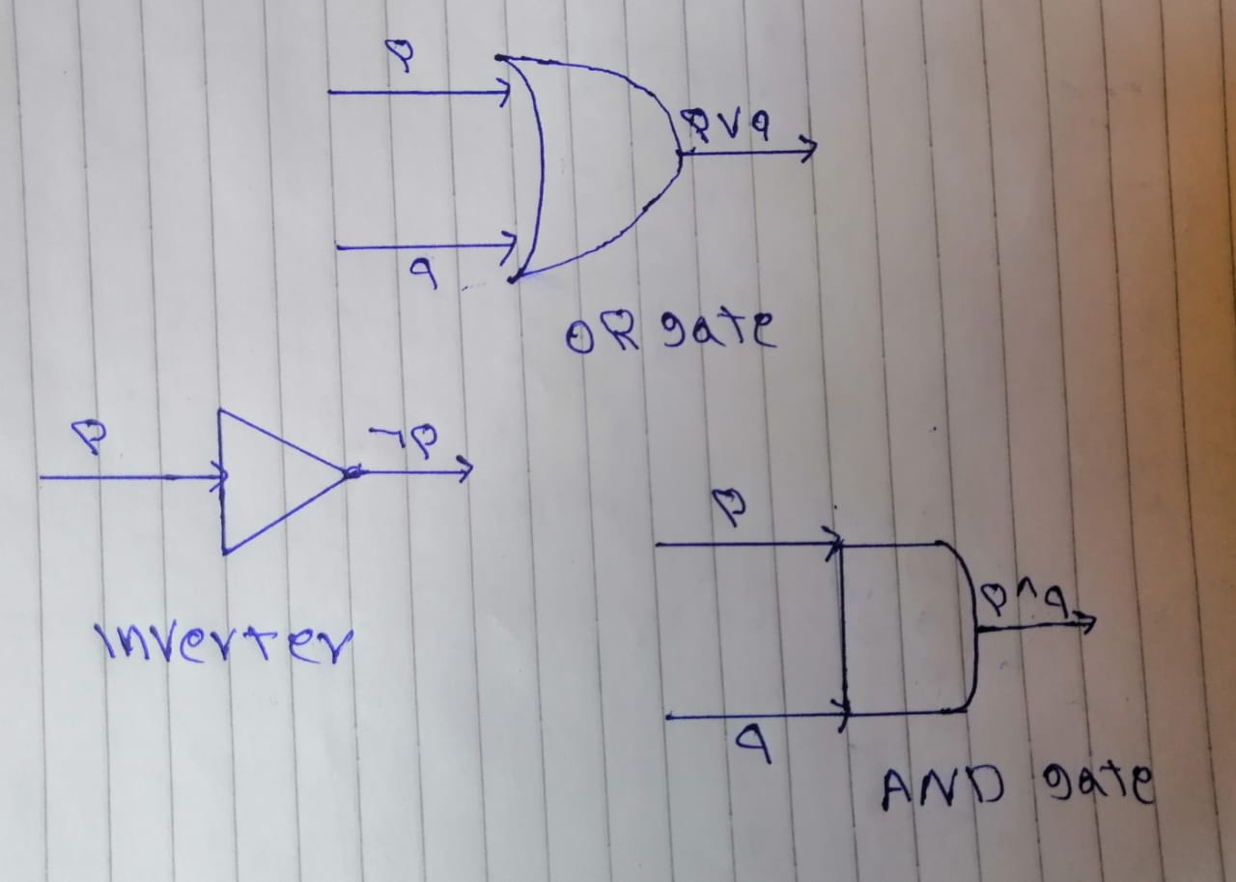
Tautology is a compound proposition that is always true no matter what the values of the propositions that occur in it. EX. P ^ q$→P$
P | q | P ^ q | P ^ q$→P$
T | T | T | T
T | F | F | T
F | T | F | T
F | F | F | T  (Tautology)
contradiction is a compound proposition that is always false. EX. $¬$(P$→$q$)$^$¬$P
P | q | P $→$q | $¬$ ( P $→$q) | $¬P$ | $¬$(P$→$q$)$^$¬$P
T | T | T | F | F | F
T | F | F | T | F | F
F | T | T | F | T | F
F | F | T | F | T | F  (contradiction)
Propositional Equivalences
$¬$ ( $¬$P ) $≡$ P & P$→$q$≡$ $¬$(P$∪$ q ) & P$↔$q $≡$ (P$→$q)^(q$→$P)
P ^ q $≡$ q ^ P & P$∪$ q $≡$ q $∪$ P
(P ^ q ) ^ r $≡$P ^( q ^ r ) & (P ^ q ) ^ r $≡$P ^( q ^ r )
P ^ ( q $∪$ r ) $≡($ P ^ q) $∪(P ^$ r ) & P $∪$ ( q $^$ r ) $≡($ P $∪$ q) $^ (P ∪$ r )
P ^ P $≡$ P & P$∪$ P $≡$ P
P ^ T $≡$ P & P ^ F $≡$ F
P$∪$ T $≡$ T & P$∪$ F $≡$ P
P ^ $¬$P $≡$ F & P $∪$ $¬$P $≡$ T
$¬$ (P ^ q ) $≡$ $¬$ P $∪$ $¬$ q & $¬$ (P$∪$ q ) $≡$ $¬$ P $^$ $¬$ q
P ^ ( p $∪$ q ) $≡$ P & P $∪$ ( p ^ q ) $≡$ P
Quantifiers ( $∋$x , $∀$x )
Quantifiers : Astatement involving a variable x is P(x) is said to be a propositional function if x is a variable and P(x) becomes a proposition when a value has been assigned to x.
$∀$x ( Universal quantifier ) For all : The set of numbers belonging to the domain and fulfills the condition , Equal And ( ^ ).
$∋$x ( Existence quantifier ) There exist : One value from the domain is sufficient to satisfy the condition , Equal Or ( $∪$ ).
Negations : (1) $¬∀$x P(x) $≡$ $∃x¬$ P(x)
: (2) $¬∃x$P(x) $≡$ $∀x¬$P(x)
predicate logic( Prolog ) : the rules are used by an important type of programming language ( Logic Programming ) , consisting of 2 types :
- Prolog facts define predicates by specifying the elements that satisfy these predicates
- Prolog rules are used to define new predicates using those already defined by Prolog facts.
nested quantifiers allows simultaneous quantification of many variables, where one quantifier is within the scope of another, such as $∀x∃y$ (x + y = 0).
Methods of Proof :
• Direct Proof • Proof by Contraposition • Proof by Contradiction • Proof by Cases
• Proof of Equivalences • Existence Proofs • Counterexamples
Sets and it `s Operations$Type equation here.$
A set ( S ) is an unordered collection of objects that are called the elements, or members.
EX. S={0,1,2,3,4,5,6} Set builder Notation : { x$∈$ N | x $≥$ 0 , x $≤$ 6 }
Special set : N , R , Q , Z , $Z^{+}$ , $Z^{_}$
The Universal Set (U) is the set containing everything currently under consideration.
The Empty Set ($∅)$is the set with no elements. Symbolized Ø, but {} also used
A Subset ($⊆$ ): if every element of A is also an element of B Or part of it: A$⊆$ B
A Proper Subset ($⊂$): if any element of A is also an element of B : A$⊂$ B
EX. { 2 , 4 , 6 , 3} $⊆$ { 2 , 4 , 6 , 3} & { 2 , 4 , 3} $⊂$ { 2 , 4 , 6 , 3}
- $∅$ $⊆$S & S$⊆$S
A=B IF A$⊆$ B , B$⊆$A
Set Operators ( $∪ , ∩ , ∱{, }- , \overset{⃑}{}, X )$
The power set of S P( S ) is the set of all subsets of the set S.
EX. S={ 1 , 2 , 3 } P( S ) ={ {1},{2},{3},{1,2},{1,3},{2,3},{1,2,3}, $∅$ }
The Cartesian product of A and B( Ax B ) is the set of all ordered pairs ( a , b ) .
EX. A={ 0,1,2 } B={ 3,4,5 }
Ax B = { (0,3) , (0,4) , (0,5) , (1,3) , (1,4) , (1,5) , (2,3) , (2,4) , (2,5) }
The union of the sets A and B( AU B ) is the set that contains those elements that are either in A or in B, or in both.
EX. A={ 0,1,2 } B={ 3,4,5 } A U B ={ 0,1,2,3,4,5 }
The union of a collection of sets ( A U B U C ) is the set that contains those elements that are members of at least one set in the collection.
EX. A={ 0,1,2 } B={ 3,4,5 } C={ 6 } A U B U C ={ 0,1,2,3,4,5,6 }
The intersection of the sets A and B ( A$∩$ B) is the set containing those elements that are in both A and B.
A $∩$ B = $∅$ That Called Disjoint
EX. A={ 0,1,4 } B={ 3,4,5 } A $∩$ B ={ 4 }
The intersection of a collection of sets( A $∩$ B $∩$ C ) is the set that contains those elements that are members of all the sets in the collection
EX. A={ 0,1,6 } B={ 3,6,5 } C={ 6 } A $∩$ B $∩$ C ={ 6 }
The difference of A and B(A–B) is the set of containing those elements that are in A but not in B.The difference of A and B is also called the complement of B with respect to A.
EX. A={ 0,1,4 } B={ 3,4,5 } A $-$ B ={ 0,1 }
The complement of the set ($\overset{⃑}{A} )$ is the complement of A with respect to U. In other words, the complement of the set A is U - A.
EX. A={ 0,1,4 } U={ 3,4,5 } $\overset{⃑}{A}=$ U $-$ A ={ 3,4 }
Equivalent Rules
$\overset{⃑}{\overset{⃑}{A} }$ =A A $∩$ B= B $∩$ A A $U$ B= B $U$ A
A U( B U C )= (A U B) U C A $∩$ ( B $∩$ C )= (A $∩$ B) $∩$ C
A $∩$ ( B U C )=( A $∩B$ ) U (A $∩$ C ) A $U$ ( B $∩$ C )=( A $UB$ ) $∩$ (A U C )
Demorgan`s Laws
$\overset{⃑}{AUB }$= $\overset{⃑}{A }∩$ $\overset{⃑}{B }$ $\overset{⃑}{A∩ B }$= $\overset{⃑}{A }U$ $\overset{⃑}{B }$
A $∩(A U B )$=A A $U(A ∩ B )$=A
A $U$ $\overset{⃑}{A }$= U A $∩$ $\overset{⃑}{A }$= $∅$
A - U=$∅$ U – A = $\overset{⃑}{A }$
A X B $≠$ B X A
Cardinality of sets
Cardinality of sets | S | : The number of Set elements
EX. S={ 2 ,5 ,8, 11, 14 } | S |=5
| A U B |=| A |+| B |-| A $∩B$ | | A X B | = |A| X | B|
| A X B X C | = |A| X | B| X | C | |P(s)|=$2^{|s|}$
Functions
F: A$→$B Each element of group A is bound by one element of group B
Where A is the domain , B is the codomain
The range, or image, of f is the set of all images of elements of A
EX. A={ a , b , c , d } B={ 1 , 2 , 3 , 4 } f(a)=1 , f(b)=2 , f(c)=3 , f(d)=4 F is Function
EX. A={ a , b , c , d } B={ 1 , 2 , 3 , 4 } f(a)=1 , f(b)=2 , f(c)= 3 F is Not Function
Types of functions
- one to one / injective
IF no two values ​​in the domain are assigned the same function value.
EX. f from {a, b, c, d} to {1, 2, 3, 4, 5} with f (a) = 4 , f (b) = 5 , f(c) = 1 and f (d) = 3 is one - to –one / injective
- Onto / surjective
IF all elements of the codomain are images of elements in the domain.
EX. F(x)=x+1 is onto / surjective
- one to one correspondence / bijective
IF it is both injective and surjective

EX. f from{a, b, c, d}to{1, 2, 3, 4} with f(a) =4 , f(b) =3 , f(c) =1 and f(d) =2 is bijective
Function operators
(f+g)(x)=f(x)+g(x) $→$ addition
(f g)(x)=f(x)g(x) $→$ multiplication
Inverse function ($f^{-1}$) : bijective EX. F(x)=x+1 F($y^{-1}$)=y-1
Composition f $°$ g (x) = f(g(x)) EX. F(x)=x+1 , g(x)=$x^{2}$ f $°$ g (x)=$x^{2}$ +1
Floor function $↳↲$
F(x) = $↳x↲$ EX. $↳2.6↲$ = 2
Celling function $↱↰$
F(x) = $↱x↰$EX. $↱2.3↰$ = 3
Sequences and summations
Sequence is a function from a subset of the set of integers. EX. {0,1,2,3,4}
Types of sequences 1) arithmetic sequence 2) geometric sequence
arithmetic sequence $a_{n}$= $a_{0}$ + $d_{n}$ EX. {1,3,5,7,9}
geometric sequence $a_{n}$= $a_{0}$ * $n^{r}$ EX. {1,2,4,8,16}
where d is comman difference , r is common ratio
summation EX. $\sum_{x=1}^{6}{x}$ = 1+2+3+4+5+6=21
Rules 1) $\sum_{x=n}^{m}{a}$ = (m-n+1)*a 2) $\sum_{x=1}^{n}{x}$ = $\frac{n(n+1)}{2}$
3)$\sum_{x=1}^{n}{x^{2}}$ = $\frac{n(n+1)(2n+1)}{6}$ 4) $\sum_{x=1}^{n}{x^{3}}$ =$\frac{n^{2}{(n+1)}^{2}}{4}$ 5)$\sum_{x=0}^{n}{ar^{x}}$ = $\frac{ar^{n+1}-a}{r-1}$ 6) $\sum_{x=0}^{∞}{r^{x}}$ = $\frac{1}{1-x}$ , |x|<1 7) $\sum_{x=1}^{∞}{xr^{x-1}}$ = $\frac{1}{{(1-x)}^{2}}$ , |x|<1
Matrices
A matrix is a rectangular array of numbers. EX. [ $\begin{matrix}2 & 5 \\ 4 & 1\end{matrix}$]
A+B IF it had the same A+B=B+A , AxB If the number of columns of array A is equal to the number of rows of array B AxB$≠BxA$
Identity matrix EX $\begin{matrix}1 & 0 & 0 \\ 0 & 1 & 0 \\ 0 & 0 & 1\end{matrix}$ boolean matrix EX. $\begin{matrix}1 & 1 \\ 1 & 0\end{matrix}$

Conclusion
Know the Importance Of Discrete Mathematics In Computer Applications.
The ability to define and understand propositional logic
Digging deeper into understanding Applications of Propositional Logic
Study both : Sets - Set Definition - Set Operations - Set Identities Functions - Types of Functions - Operations on Functions – Computability Sequences and Summations - Types of Sequences - Summation Formulae Matrices - Matrix Arithmetic

References
[1] Kenneth H. Rosen. Discrete Mathematics and Its Applications, 7th Edition. McGraw Hill, 2012.(book)
[2] ENUMERATIVE COMBINATORICS (Discrete Mathematics and its applications)
[3] COMBINATORICS OF COMPOSITIONS AND WORDS (Discrete Mathematics and its applications) 2010 by Taylor and Francis Group, LLC Discrete Mathematics and its applications Series Editor Kenneth H. Rosen, Ph.D. J...Author: Silvia Heubach | Toufik Mansour
[4] https://www.ekb.eg/ar/home
[5] https://scholar.google.com/schhp?hl=en&as_sdt=0,5
[6] https://libgen.is/
[7] https://www.youtube.com/playlist?list=PLPn4eVPZKtrJazcnVtNv3MF-aGuEVrD5E

